Non-Coplanar Points
# Source: AI Source: Provided by: [Data Path: Persons Table -> ID Column: 1, Name_En Column: Motasem Essam] -> From: [ChatGPT] on [7/25/2026]
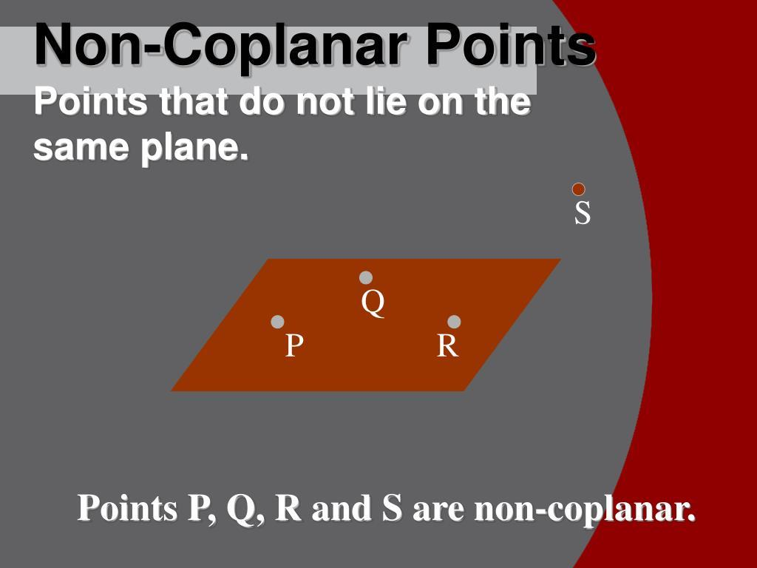
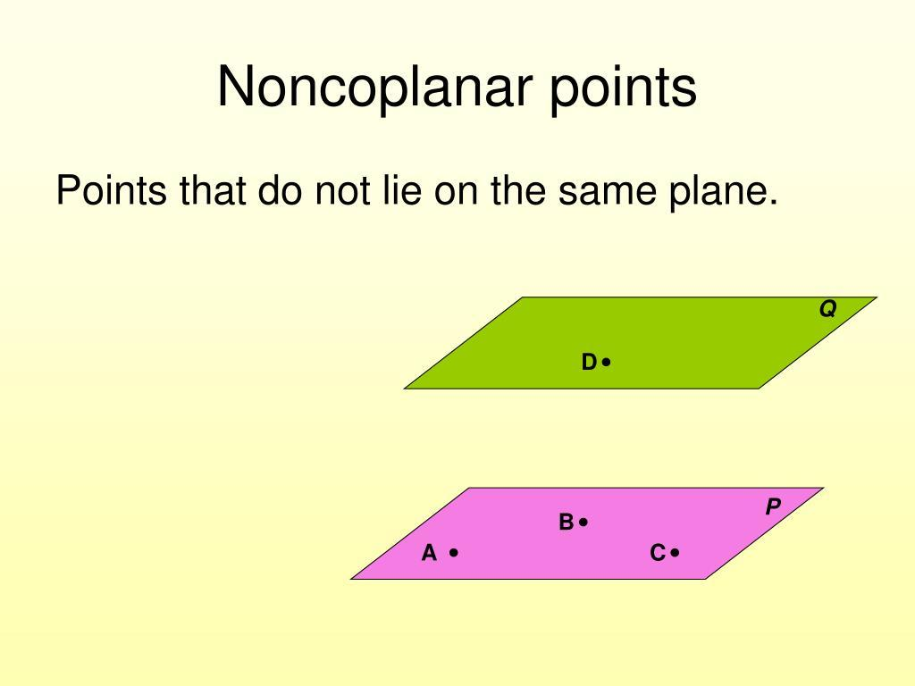
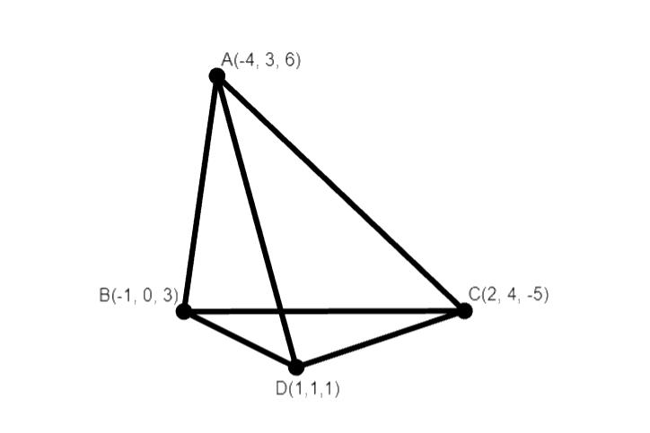
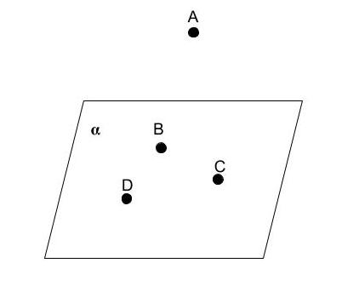

Definition
# Source: AI Source: Provided by: [Data Path: Persons Table -> ID Column: 1, Name_En Column: Motasem Essam] -> From: [ChatGPT] on [7/25/2026]
Non-Coplanar Points are two or more points that do not all lie on the same plane. If no single plane can contain all of the points simultaneously, they are said to be non-coplanar.
Non-coplanar points represent a three-dimensional arrangement and are fundamental in solid geometry.

Characteristics
# Source: AI Source: Provided by: [Data Path: Persons Table -> ID Column: 1, Name_En Column: Motasem Essam] -> From: [ChatGPT] on [7/25/2026]
Non-coplanar points:
- Do not all lie on one plane.
- Form a three-dimensional configuration.
- Cannot all be contained within a single flat surface.
- Are used to define solid geometric objects.
- Exist only in three-dimensional (or higher-dimensional) space.

Illustration
# Source: AI Source: Provided by: [Data Path: Persons Table -> ID Column: 1, Name_En Column: Motasem Essam] -> From: [ChatGPT] on [7/25/2026]
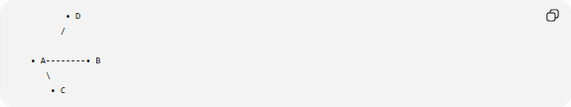
• D
/

• A--------• B
\
• C
Points A, B, and C lie on one plane, while point D is outside that plane. Therefore, the four points are non-coplanar.

Examples
# Source: AI Source: Provided by: [Data Path: Persons Table -> ID Column: 1, Name_En Column: Motasem Essam] -> From: [ChatGPT] on [7/25/2026]
Vertices of a Tetrahedron

A
/|\
/ | \
B--|--C
\ |
\|
D
The four vertices of a tetrahedron are non-coplanar, because no single plane contains all four points.

Three-Dimensional Coordinates
# Source: AI Source: Provided by: [Data Path: Persons Table -> ID Column: 1, Name_En Column: Motasem Essam] -> From: [ChatGPT] on [7/25/2026]
Consider the points:
$$A\left(0 , 0 , 0\right) \\ B\left(2 , 0 , 0\right) \\ C\left(0 , 2 , 0\right) \\ D\left(0 , 0 , 2\right)$$
Points A, B, and C lie on the plane:
$$z=0$$
Point D does not lie on this plane, so the four points are non-coplanar.

Mathematical Description
# Source: AI Source: Provided by: [Data Path: Persons Table -> ID Column: 1, Name_En Column: Motasem Essam] -> From: [ChatGPT] on [7/25/2026]
Four or more points are non-coplanar if no single plane can contain all of them.
In three-dimensional coordinate geometry, this means at least one point does not satisfy the equation of the plane determined by the others.

Properties
# Source: AI Source: Provided by: [Data Path: Persons Table -> ID Column: 1, Name_En Column: Motasem Essam] -> From: [ChatGPT] on [7/25/2026]
Non-coplanar points:
- Occupy three-dimensional space.
- Cannot all lie on one plane.
- Can define solid figures.
- May form the vertices of polyhedra.
- Are essential in solid geometry.

Applications
# Source: AI Source: Provided by: [Data Path: Persons Table -> ID Column: 1, Name_En Column: Motasem Essam] -> From: [ChatGPT] on [7/25/2026]
Non-coplanar points are used in:
- Solid Geometry
- Coordinate Geometry
- Engineering
- Architecture
- Structural Design
- CAD (Computer-Aided Design)
- Computer Graphics
- Robotics
- GIS (Geographic Information Systems)
- 3D Modeling

Advantages
# Source: AI Source: Provided by: [Data Path: Persons Table -> ID Column: 1, Name_En Column: Motasem Essam] -> From: [ChatGPT] on [7/25/2026]
Studying non-coplanar points helps to:
- Model three-dimensional objects.
- Analyze spatial relationships.
- Construct solid geometric figures.
- Support engineering and architectural design.
- Improve three-dimensional visualization.

Limitations
# Source: AI Source: Provided by: [Data Path: Persons Table -> ID Column: 1, Name_En Column: Motasem Essam] -> From: [ChatGPT] on [7/25/2026]
Non-coplanar points:
- Cannot be analyzed using only plane geometry.
- Require three-dimensional coordinate systems.
- Often involve more complex calculations than coplanar configurations.

Comparison with Coplanar Points
# Source: AI Source: Provided by: [Data Path: Persons Table -> ID Column: 1, Name_En Column: Motasem Essam] -> From: [ChatGPT] on [7/25/2026]

Type | Description
Coplanar Points | All lie on the same plane
Non-Coplanar Points | Do not all lie on the same plane

Key Points
# Source: AI Source: Provided by: [Data Path: Persons Table -> ID Column: 1, Name_En Column: Motasem Essam] -> From: [ChatGPT] on [7/25/2026]
- Non-Coplanar Points do not all lie on a single plane.
- They form a three-dimensional arrangement.
- They are essential for constructing solid figures such as tetrahedra and other polyhedra.
- Non-coplanar points are widely used in engineering, architecture, CAD, robotics, GIS, and computer graphics.

Conclusion
# Source: AI Source: Provided by: [Data Path: Persons Table -> ID Column: 1, Name_En Column: Motasem Essam] -> From: [ChatGPT] on [7/25/2026]
Non-Coplanar Points are points that cannot all be contained within a single plane, making them fundamental to the study of three-dimensional geometry. They describe spatial arrangements that extend beyond flat surfaces and are essential for modeling solid objects and analyzing spatial relationships. Non-coplanar points play a vital role in solid geometry, engineering, architecture, structural design, CAD, computer graphics, robotics, GIS, and scientific visualization, where accurate representation of three-dimensional space is required.

